# **CS 470 Module One Assignment Guide**

## Introduction

In this lesson, you will gain exposure to using Docker. In previous courses, you downloaded and installed MongoDB onto your own computer and then developed applications to use it. Before your application can run on another computer, the correct version of MongoDB must be installed there. Installing software also means that your computer’s configuration and settings are altered, which may impact other software you have installed. Additionally, there is a risk that the other computer or its installation of MongoDB are not configured identically to your machine.

To overcome this common situation, you should run MongoDB inside a container. Moving the container to a new computer brings all the configuration and settings along as well. Practice using a pre-built Docker container with MongoDB already installed and configured.

## Summary Steps

* Install [Docker Desktop](https://www.docker.com/products/docker-desktop).
* Open Docker Dashboard.
* Ensure Docker is running.
* Open the PowerShell prompt.
* Create a default MongoDB container with the following commands:
  + docker pull mongo
  + docker run -d -p 27017-27019:27017-27019 --name mongodb mongo
  + docker exec -it mongodb bash
    - mongo
    - use admin
    - show dbs
    - **Ctrl+D** (exit mongo shell)
    - **Ctrl+D** (exit Docker remote bash shell)

## Detailed Steps

Open Docker Dashboard by right-clicking on the Windows System Tray icon.

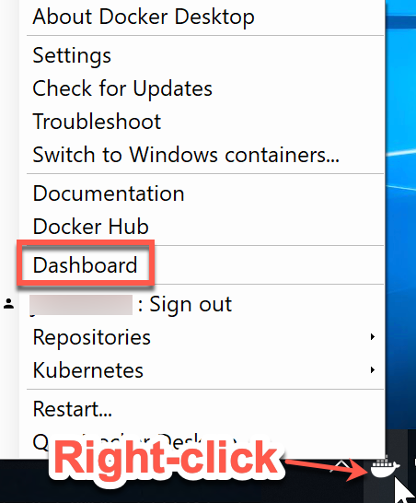

Ensure Docker is running. The icon to the lower left of the dashboard should be green.

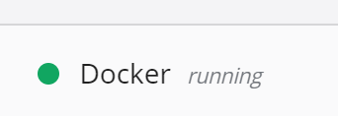

Use the [pull](https://docs.docker.com/engine/reference/commandline/pull/) command to retrieve a pre-built and configured image from the [Docker Registry](https://hub.docker.com/):

> docker pull mongo

Use the "pull" command to retrieve a pre-built and configured image from the Docker Registry: 
> docker pull mongo


Note: The Docker Registry has official container images from many popular vendors and open source projects, including operating systems, databases, web servers, applications, and programming environments. Be careful, as you may find yourself up all night checking out the software available at your fingertips!

Use the Docker [run](https://docs.docker.com/engine/reference/commandline/run/) command to start the container:

> docker run -d -p 27017-27019:27017-27019 --name mongodb mongo

Use the Docker "run" command to start the container: 
> docker run -d -p 27017-27019:27017-27019 --name mongodb mongo

***-d*** *means “detach” the console from the container so it runs in the background and lets you use additional commands in your window.*

***-p 27017-27019:27017-27019*** *means to map the range of ports on your computer to the range of ports listed after the colon inside the container.*

***-- name mongodb*** *is the friendly name you wish to assign to the container.*

***mongo*** *is the name of the image you just pulled down from the registry.*

Note: The long string of characters displayed after the run command is the unique instance identifier of the container.

Use the Docker [images](https://docs.docker.com/engine/reference/commandline/images/) command to view the installed images on your computer:

> docker images

Use the Docker "images" command to view the installed images on your computer:
> docker images

You will also see the new container in the Docker Dashboard.

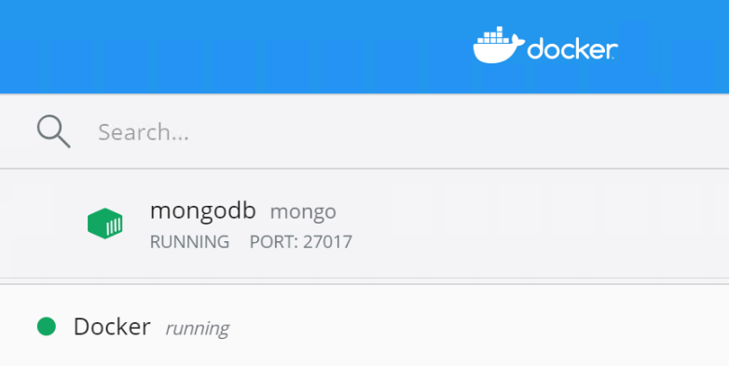

Use the Docker [exec](https://docs.docker.com/engine/reference/commandline/exec/) command to execute a command within the running container. To open a bash shell session inside the container, use the following command:

> docker exec -it mongodb bash

To open a bash shell session inside the container, use the following command:

> docker exec -it mongodb bash

Below this command is the following code:
root@eld5ffe938fb:/ uname -a 
Linux eld5ffe938fb 4.19.76-linuxkit #1 SMP Thu oct 17 19:31:58 UTC 2019 x86_64 x86_64 x86_64 GNU/Linux
root@eld5ffe938fb:/# 

"uname -a" and "root@e1d5ffe938fb" are underlined in red. 

***-it*** *means the command will be run interactively and the input/output will be reflected in your local console terminal (window).*

***mongodb*** *is the friendly name of the container that you want the command to run in.*

***bash*** *is the name of the command to execute.*

Note: The “uname -a” command prints information about the machine. As you can see, even though the host computer is running Windows 10 and the blue window is a PowerShell command window, the remote container is running Linux! The “root@e1d5ffe938fb” on the shell prompt indicates the user and hostname of the machine running inside the container. Advanced tip: The hostname is the first several characters of the unique container ID shown earlier.

Until you exit the remote bash shell, anything you type will be run inside the container, as if your display and keyboard were connected directly to the Linux computer in there. Try the following commands:

> mongo #launch the MongoDB shell use this insted(mongosh)

> use admin #use the admin database

> show dbs #list the databases

> exit #exit mongo shell

> exit #exit Docker remote bash shell

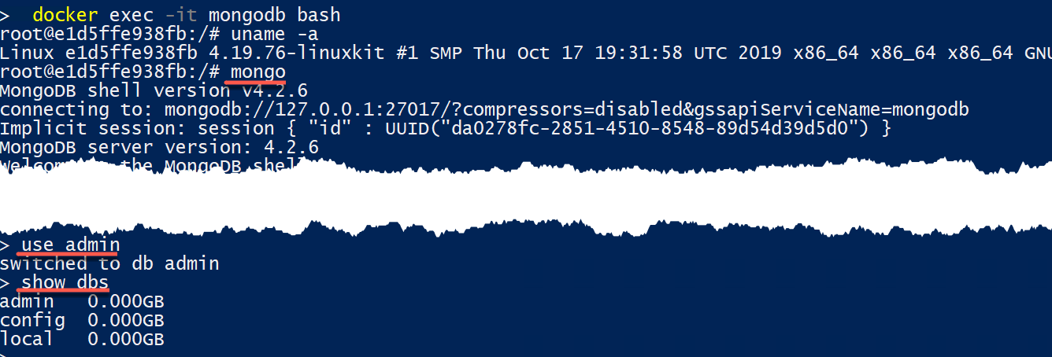

Note: You can press **Ctrl+D** to signal “exit” instead of typing out the word. Over time, shortcuts like this will save you time.

Notice the container is running MongoDB version 4.2.6. It is possible to use different versions by specifying the version number on the Docker pull command.

Use the [Docker stop](https://docs.docker.com/engine/reference/commandline/stop/) command to stop the container and free up resources (memory, processor) on your computer:

> docker stop mongodb

## Optional

You can visit the [Docker Hub](https://hub.docker.com/search?type=image&image_filter=store%2Cofficial) and try taking other images for a spin. One important concept to note: Containers are intended to be smaller and lighter-weight than full virtual machines, so graphical interfaces are not possible. If, for example, you wished to try out Ubuntu and get the full experience, you should instead use a virtual machine since VMs support the full set of hardware on your machine – mouse, USB memory sticks, printers, scanners, and so on.